EXPERIMENT-4
INPUT:
#include <iostream>
using namespace std;
int call_value(int a, int b)
{int temp = a;
a = b;
b = temp;}
int call_ref(int &a, int &b)
{ int temp = a;
a = b;
b = temp;}
int call_address(int *a, int *b)
{ int temp = *a;
*a = *b;
*b = temp;}
int main()
{ int n1, n2;
cout << " enter the value for n1 and n2 : ";
cin >> n1 >> n2;
cout<<"the value of n1 and n2 is before call by value : "<<n1<<" "<<n2<<endl;
call_value(n1, n2);
cout<<"the value of n1 and n2 is after call by value : "<<n1<<" "<<n2<<"\n\n";
cout<<"the value of n1 and n2 is before call by reference: "<<n1<<" "<<n2<<endl;
call_ref(n1, n2);
cout<<"the value of n1 and n2 is after call by reference : "<<n1<<" "<<n2<<"\n\n";
cout<<"the value of n1 and n2 is before call by Address : "<<n1<<" "<<n2<<endl;
call_address(&n1, &n2);
cout<<"the value of n1 and n2 is after call by Address : "<<n1<<" "<<n2<<endl;
}
OUTPUT:
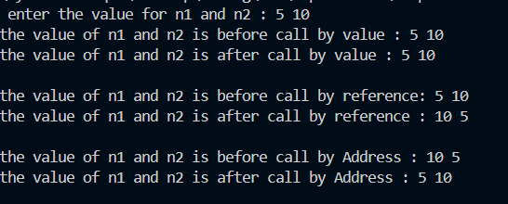
EXPERIMENT-5a
INPUT:
OUTPUT:
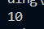
For public:
#include <iostream>
using namespace std;
class number
{
public:
int n = 10;
};
int main()
{
number n1;
cout << "the value of number is : " << n1.n;
return 0;
}
For private:
#include <iostream>
using namespace std;
OUTPUT:
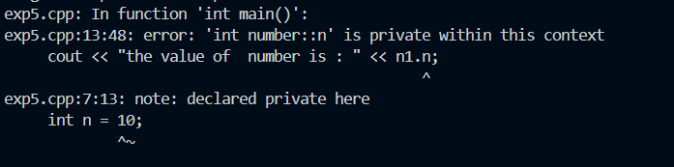
class number
{
private:
int n = 10;
};
int main()
{
number n1;
cout << "the value of number is : " << n1.n;
return 0;
}

For protected:

#include <iostream>
using namespace std;
OUTPUT:
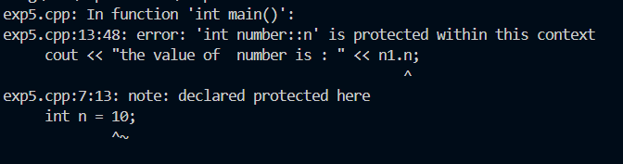
class number
{
private:
int n = 10;
};
int main()
{
number n1;
cout << "the value of number is : " << n1.n;
return 0;
}

